Final Econometric Analysis
Applied Econometrics 1
Dr. Todorov
9/29/2024

Milestone 1
Description
The issue that I wish to address is to see if median income in 2022 had a statistically significant relationship to both heart disease and diabetes mortality rates in various selected states in the United States. Additionally, I am also looking to see if BMI (defined obese which is calculated as 30 and above) as well as Education Level (defined as bachelor’s degree attainment) has a significant or disproportionate impact on these states. These resources are relevant in the following ways. Primarily, if a causal relationship is seen to exist in the cross-sectional data for 2022, this could help stimulate more research efforts to enhance our understanding of how economic policy can impact chronic health conditions and morality. Secondly, a compelling example could be to provide more awareness to these impacts and hopefully inspire more research to help policymakers and individuals make better decisions and allocate resources more effectively to mitigate these effects. Also, states themselves could help provide effects to their policies or operations to help lessen the severity or frequency of these mortalities.
I believe the target audiences would include both technical and non-technical readers. For example, health care professionals and economists will find this research relevant because including statistical and relevant information on confounding variables can help illustrate what specifically could be used to help in providing decisions to manage, interpret and educate broader healthcare resource management and falsifiability. They also shape this paper by allowing me to explain how my results were established giving others the ability to disprove or expound on the given conclusions. Additionally, the brevity and simplicity of my conclusions and abstractions are influenced by the non-technical public. They will also find this information relevant to help them understand or address concerned loved ones and leaders on what they could do to help ease these potential effects.
Literature Review: Methods and Techniques
There has been a wide array of various techniques used to study the relationships between various economic variables, health indicators and disease. One interesting study by Dr. M. Harvey Brenner looked at the inverse relationship between fluctuation in New York State employment indexes and changes in total heart disease mortalities. There was various sectional analysis performed but the relationship was analyzed using Fourier analysis to look at the relationship in employment indexes and heart mortalities using first differences average in 4–5-year changes.
Additionally, these first differences where then examined in terms of moving averages and determined by polynomial curve fitting. Lastly, correlations between indexes and heart mortality were preformed and Fourier analysis was used to determine the time frame in which lag effects began to influence changes in heart mortalities. (Brenner, 1971) Another interesting study was done in Jamacia which attempted to look at macroeconomic variables such as GDP, Inflation Rates and their relationship to Murder, Morality and Ill Health. Statistical techniques that were employed for this study included correlational analysis (Pearson) to look at the bivariate correlations between macroeconomic variables and mortalities and murder. In addition, best fit models such as OLS (Ordinary Least Square) and multiple regression analysis were used to see possible explanatory variables. (Andrew Bourne et al., 2014)
Econometrically, these issues have been addressed using the various techniques listed above. Hypothesizes have been formulated, estimations of parameters have been set and data analysis has been done to statistically test the significance of these predictor variables to their dependent variables. Lastly, interpretation of these results was published for evaluation and conclusions were objectively stated. I believe a significant portion of the mentioned studies have implemented the appropriate methods and techniques but not without come caveats and issues. One of the most pressing issues I see in these selected studies especially from Brenner was the omission of confounding variables in their analysis. Additionally, even with Fourier analysis to specify with relative precision the probable lag times between indexes in employment and changes in heart mortalities, this still does not represent nor conclude causality from that specific instance alone. Regardless of patterns or cycles shown though Fourier analysis in time series data and strong correlative connections between variables, (-.08 and -.09) more analysis for controlling confounding variables should be addressed to strengthen the casual relationship between predictors and their dependent variables. Additionally, the data sets should have been tested for significance of outliers (z-scores, Grubbs) as well as possible testing for normality of distribution (Shapiro-Wilk) before looking at regression or correlative relationships.
The hypothesis I plan to test is a cross-sectional analysis of heart and diabetes morality rates to median income for 2022. Specifically, I want to see if there is there a significant relationship between median income and mortality rates for diabetes and heart disease across various states in the United States in 2022. The specific states that I selected include Alabama, Alaska, Arizona, Arkansas, California, Colorado, Connecticut, Delaware, District of Columbia, Florida, Georgia, Hawaii, Idaho, Illinois, Indiana, Iowa, Kansas, Kentucky, Louisiana, Maine, Maryland, Massachusetts, Michigan, Minnesota, Mississippi, Missouri, Montana, New York, Ohio, Pennsylvania, Texas, Washington. I believe this is a good sample of various regions in the United States as well as varying populations and demographics. This hypothesis can translate into the following model. My independent variable will be median income with both diabetes and heart disease mortality rates representing our dependent variables. Additionally, my confounding variables will include BMI as well as Education Level. We can run a simple multiple regression analysis to see if there exists a relationship between the two dependent variables and my selected independent variables. Secondly, we will set our significance value and determine if a significant p-value exists. Our standard significance level will be set at 0.05. The null hypothesis will be that there is no significant relationship between median income, BMI and Education Levels and Diabetes and Heart Disease Mortality Rates in various selected states for 2022. Our alternative hypothesis is that there is a significant relationship between Median Income, BMI and Education Level and Diabetes and Heart Disease Mortality Rates in various selected states for 2022. Lastly, we will need to look at some assumptions in our model including linearity, fitness of data (outliers) etc. as well as accessing our confounding variables to allow us to see if other relationships are occurring between our independent variables. (multicollinearity)

Data
For economic statistics, I will be using the datasets from the United State Census as well as BLS on Median Household Income by state for 2022. This was culled and assembled by the FRED for analysis. This is also culled from Current Population Survey, CPS ASEC (Annual Social and Economic Supplement) as well as the American Community Survey. (FRED, 2022a) (Household Income in States and Metropolitan Areas: 2022, 2023) For mortality statistics I will use the CDC’s National Center for Underlying Cause of Death Statistics using CDC’s Wonder Database. The diabetes death rate data was pulled from Centers for Disease Control and Prevention, National Center for Health Statistics. Underlying Cause of Death 1999-2021 on CDC Wonder Database Online. Data are from the Multiple Cause of Death Files, 1999-2022. (Centers for Disease Control and Prevention (2021) The CDC sources were gathered and complied by 57 vital statistics jurisdictions through the Vital Statistics Cooperative Program. (Kaiser Family Foundation, 2022) Additionally heart disease mortality rates were gathered from National Center for Health Statistics from CDC. (Centers for Disease Control and Prevention (2022) For information on BMI, data was gathered from BRFSS Prevalence & Trends Data: Explore by Topic (CDC, 2022) Lastly, with regards to educational attainment, data was culled from Educational Attainment, Annual: Bachelor’s Degree or Higher by State which pulls from ACS etc. (FRED, 2022b)
These data sets are appropriate for a variety of reasons. Primarily, though the data accessed was secondary, the source of the data was achieved through direct collection from the CDC’s Vital Statistics Cooperative Program. Secondly, the data is comprehensive and contains death rates and primary collected death totals from death certificate sources. Additionally, the data contains a wide range of regions (including every state in the US) which makes it comprehensive and meticulous for comparative analysis. (Crooks, 2020) Lastly, the data is current for the year 2022 and the CDC and BLS are both reliable sources due to their rigorous standards and credibility. However, some biases and issues could affect the reliability of these data sets in the following ways. Being as the CDC in this usage collected the information themselves, some of the data may also be obtained though other primary care sources. According to Verheij et al, data sources that contain or are collected for different processing steps and purpose and pose biases to these data though out the data lifecycle. Also, some of this data can be related to the structure of the institute doing the data as well as technical biases. (Verheij et al., 2018) For BLS data, substitution effects and quality adjustment biases can be present when quality of goods increases (which can be difficult to adjust and may not be accurate) or when consumer substitution cheaper goods for causing an overestimation in cost of living. Hausman (2002). Also, from Hausman, “Bils and Klenow (2001) finds (found) a significant estimate of quality bias over the period 1980-1996” (Bils & Klenow, 2001) (Hausman (2002).
The type of data provided from these data sets included categorical, descriptive data as well as quantitative and structured data sets. (United States Security and Exchange Commission, 2016) (Kearney, n.d.) For information on median income, information was provided using table data sets as well as graphical charts showing various median incomes by state. (FRED, 2022a) (Household Income in States and Metropolitan Areas: 2022, 2023) Additionally, median incomes for 2022 are continuous data and contain no absolute zero reference due to its calculation that non earnings were recorded for this specific period. This, however, does not mean that there was a complete absence of economic value, production or activity. For the CDCs information, the type of data includes structured data sets with both discrete data (number of deaths by state) as well as continuous data (death rates for both heart disease and Diabetes mortalities). Also, categorical and nominal data is shown though state selection for specific death rates and mortalities. Additionally, death counts and rates have absolute zero reference. With a simple data screening process, both data sets for Diabetes and Heart Disease mortality rates appear to be complete with no missing entries from the selected states in question for our hypothesis. I will be examining 32 states listed previously. These states help represent various regions of the United States in cross sectional analysis for 2022. For instance, correlation values were performed to check for a potential relationship between diabetes and heart mortalities (dependent variables) for 2022 for the listed states above. The result concluded that the relationship between heart and diabetes moralities was 0.35 indicating a relatively weak relationship. This implies that the relationship between these variables appears to not be influencing each other though more tests may need to be done to determine the relationship. Lastly, multicollinearity was found to be within good range from 2.59 and 3.31 for Variance Inflation Factors.
In addition, an outlier test (Grubbs Test) was performed to see what state may be skewing the data. The relationship between the two dependent variables as well as all independent variables showed that no statistically significant outlier was present in our data sets. However, one value Education Level 14 D.C was found significant. This will later be removed when we observe our cook and leverage values to ascertain other factors that could be skewing our data sets. Additionally, we will then eliminate these data points from our regression to then analyze changes in our model. The implication of these univariant sets gives us the indication that these sets have no significant deviations from their means or may be influencing our outcomes outside of this one observation within this test.
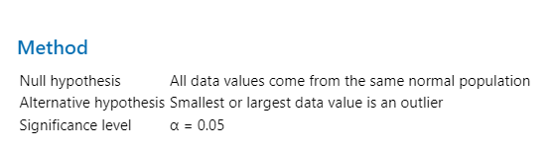
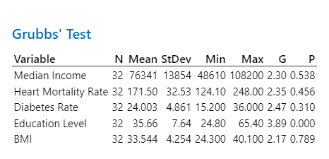

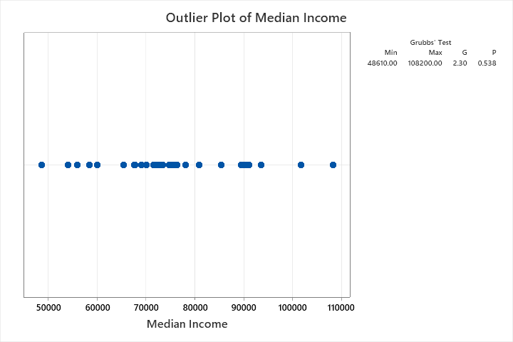
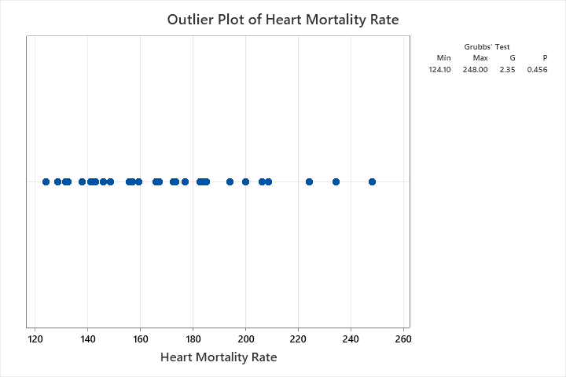
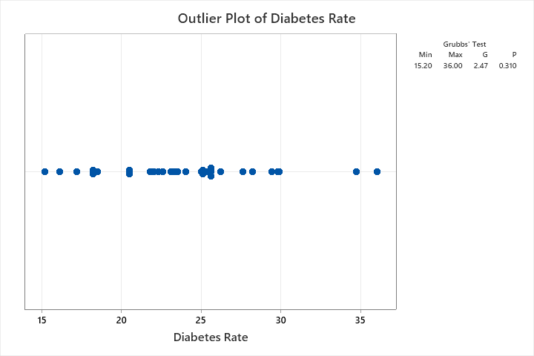
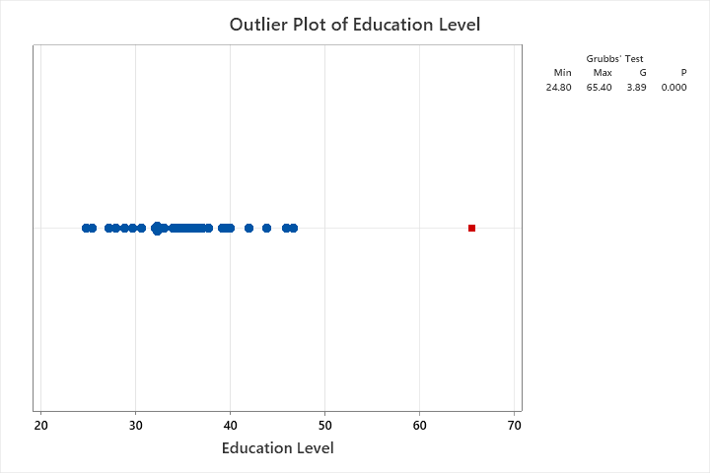
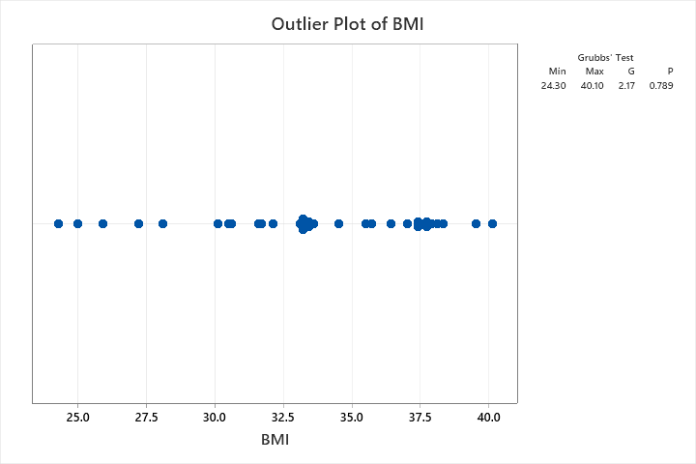

Several factors could indicate that these relationships and findings could be misleading. Firstly, the relationship of our dependent variables could be nonlinear. This means that the correlation could be related in other ways such as quadradic or exponential. (Pham, 2022) Secondly, our data ranges within this set maybe too low which can lead to low correlations, we may need more data to help with this situation. Lastly, we could be seeing confounding variables that might be affecting our relationships. Things like diet, exercise, differences in health care by state etc. could be causing spurious, masking effects on our dependent relationships. (Pham, 2022)

References
Andrew Bourne, P., Mills , M., Campbell-Smith, J., Sharpe-Pryce, C., Francis, C., Solan, I., & Davis , A. H. (2014). The Influence of Macroeconomic Variables on Health Indices, Murder and Mortality: A Case of Jamaica. Journal of General Practice, 02(02). https://doi.org/10.4172/2329-9126.1000145
Bils, M., & Klenow, P. J. (2001). Quantifying Quality Growth. American Economic Review, 91(4), 1006–1030. https://doi.org/10.1257/aer.91.4.1006
Brenner, M. H. (1971). Economic changes and heart disease mortality. American Journal of Public Health, 61(3), 606–611. https://doi.org/10.2105/ajph.61.3.606
CDC. (2022). BRFSS Prevalence & Trends Data: Explore by Topic | DPH | CDC. Nccd.cdc.gov. https://nccd.cdc.gov/BRFSSPrevalence/rdPage.aspx?rdReport=DPH_BRFSS.ExploreByTopic&irbLocationType=StatesAndMMSA&islClass=CLASS14&islTopic=TOPIC09&islYear=2022&islLocation
Centers for Disease Control and Prevention. (2021). CDC WONDER. Cdc.gov; CDC.gov. https://wonder.cdc.gov/
Centers for Disease Control and Prevention. (2022, February 25). Stats of the States - Heart Disease Mortality. Centers for Disease Control and Prevention. https://www.cdc.gov/nchs/pressroom/sosmap/heart_disease_mortality/heart_disease.htm
Crooks, R. (2020, February 25). How to Find Accurate and Compelling Data. Blog.hubspot.com. https://blog.hubspot.com/marketing/find-good-data
FRED. (2022a). 2020, Release Tables: Real Median Household Income by State, Annual | FRED | St. Louis Fed. Fred.stlouisfed.org. https://fred.stlouisfed.org/release/tables?eid=259515&rid=249
FRED. (2022b). 2021, Educational Attainment, Annual: Bachelor’s Degree or Higher by State | FRED | St. Louis Fed. Fred.stlouisfed.org. https://fred.stlouisfed.org/release/tables?eid=391444&rid=330
Hausman, J. (2002). NBER WORKING PAPER SERIES SOURCES OF BIAS AND SOLUTIONS TO BIAS IN THE CPI. https://www.nber.org/system/files/working_papers/w9298/w9298.pdf
Household Income in States and Metropolitan Areas: 2022. (2023). KEY DEFINITIONS. https://www.census.gov/content/dam/Census/library/publications/2023/acs/acsbr-017.pdf
Kaiser Family Foundation . (2022, April 27). Number of Diabetes Deaths per 100,000 Population. KFF. https://www.kff.org/other/state-indicator/diabetes-death-rate-per-100000/?currentTimeframe=0&sortModel=%7B%22colId%22:%22Location%22
Kearney, C. (n.d.). Library Guides: Data Literacy: Data Types and Formats. Libguides.tulane.edu. https://libguides.tulane.edu/datalit/types
Pham, K. (2022, February 8). What Could Go Wrong: Linear Regression. Medium. https://vkhangpham.medium.com/what-could-go-wrong-linear-regression-517f9823241f
United States Security and Exchange Commission . (2016, March 26). About Structured Data. SEC.gov. https://www.sec.gov/structured-disclosure/structured-data-about. Published data was put as updated and reviewed date.
US Inflation Calculator. (2019, May 10). Consumer Price Index Data from 1913 to 2019. US Inflation Calculator. https://www.usinflationcalculator.com/inflation/consumer-price-index-and-annual-percent-changes-from-1913-to-2008/
Verheij, R. A., Curcin, V., Delaney, B. C., & McGilchrist, M. M. (2018). Possible Sources of Bias in Primary Care Electronic Health Record Data Use and Reuse. Journal of Medical Internet Research, 20(5), e185. https://doi.org/10.2196/jmir.9134

Milestone 2

Data
The data that I am using for my analysis will be as follows: For mortally and diabetes rates, I will use CDCs Wonder database. (Centers for Disease Control and Prevention (2022) (KFF, 2024) For my independent variables, I will be using information from the FRED and gathered and collected from the Bureau of Labor Statistics on annual median household incomes. (FRED, 2022a) (Household Income in States and Metropolitan Areas: 2022, 2023) Centers for Disease Control and Prevention (2022) Finally, to see if other confounding variables could be accounting for the explanation in the relationship to mortality rates, I will be utilizing information from the CDC
Limitations
Several limitations could affect the robustness and accuracy of our multiple regression analysis. Primarily, the data sources listed provide excellent quality and completeness. In addition, the resources provided use precise measuring and data collection methods (stated previously) across all selected states and by year. However, regardless of their robustness, one primary cause for concern would be the obesity, confounding variable and how it is addressed. The variable examined by the CDC was calculated from one or more BRFSS questions. (CDC, 2022) If these questions were poorly worded or if the consistency of the questions were not answered correctly, we could see some negative effects on our empirical methods. According to psychological data, sensitivity in subject responses such was weight etc. can be highly misreported according to the situation. (Tourangeau & Yan, 2007) This misreporting of information could give us unreliability in our assessment of this variable and can relate inflated or deflated bias effects in our output. However, the CDC does construct survey methods and confidence intervals to statistically screen out these potential effects, but they still could impose issues on the regression models and empirical methods. (CDC, 2022) Another vital component that is not usually talked about that will always prose a significant problem is the culture context as well as the policy, economic and demographical variables that can skew the collected data. For data, it’s been noted that cultural beliefs can shape health attributions as well as reporting, beliefs about disease etc. (Vaughn et al., 2009) With the United States being a large county by size and population, the reliability of the data collection could be affected.
Empirical Approaches
The best empirical approach I suggest for looking at these relationships would be a multiple regression analysis. The reasons for this are because with a multivariable approach, I can control for my confounding variables accurately to help isolate the effects that the selected predictors could have on heart disease and diabetes mortality rates. In addition, its brevity and methodology have been backed by the large scientific community especially in terms of social science. (Mohr et al., 2021) Additionally, other methods such as multilevel or Structural Equation Modeling (SEM) are either too complex in their interpretation or specificity, or their data requirements are too strict in terms of sample size (which could be extensively high for hierarchy modeling and SEM). (Beran & Violato, 2010) Another final note is that SEM models require ample assumptions about normality etc. which might not translate effectively to the real-world applications. (Gao et al., 2008)
Multiple regression is easy to use, has less stringent assumptions and is easier to implement and understand.

Limitations of Regression Models and Alternative Methods
Several assumptions need to be made for a regression analysis to be performed, interpreted and executed effectively. One primary limitation and violation of the assumptions made for these regressions, is the normality of residuals in datasets and analysis. According to Greene’s comprehensive chapter on the subject, Greene points out that even while OLS estimates can remain unbiased and consistent, efficiency and accuracy of these estimators can still be affected from autocorrelation and heteroskedasticity. One cause of these limitations can arrive from smaller data sets. It is also argued by Greene (and elsewhere) that when the sample size of a set increases then the distribution of OLS estimators will naturally approach normality due to Central Limit Theorem. (Greene, 2017) Another bulky issue that can occur with regression models is that of causality and endogeneity. Though different types of endogeneity can exist, one specific instance that occurs through data is sample selection bias. James J Heckman’s paper “Sample Selection Bias as a Specification Error," illustrates that limitations in the output of regression methods can be greatly affected if the mechanism of selection is not independent of the outcome variable. Thusly, biases occur due to unnoticed factors influencing data selection processes and thus are correlated with the error term in the outcome equation. Additionally, this can also occur due to variables not being accounting for that may be interacting. If these variables are unaccounted for, then we see increased biases in our estimations, conclusions and inferences. (Heckman, 1979) Finally, other crucial limitations with regression methods can be their tendency to overfit as well as being unaware if two independent variables are correlated with each other (multicollinearity). Burhman and Anderson in their book, “Model Selection and Multimodel Inference: A Practical Information-Theoretic Approach” talk about this extensively. This can occur when too many variables or redundant variables allow for a close fitting to training data and capturing true underlying patters as well as noise. However, Burhman and Anderson discuss ways to combat this with both Akaike Information Criterion as well as Bayesian Information Criterion which imposes various degrees of penalties relative to the number of predictors used. (Burnham et al., 2002)
Several alternative methods could be utilized instead of regression analysis. These can include Structural Equation Modeling (SEM), Hierarchical Linear Modeling (HLM) or Multilevel Modeling. SEM can be appropriate if the constructs could be affecting both our independent and dependent variables. Also, complexity of predictors can be utilized. In addition, with our analysis of individuals level health outcomes (like mortalities and median income performance variables) HLM can take regression one step further and model predictors at different levels of aggregation. (Raudenbush & Bryk, 2002) However, as discussed previously there are several more limitations in terms of permissible data as well as implementation that can increase the complexities and usages of these models. (Kline, 2015, pp. 79–105, 239–275.)
Specification
For the functional form of the data, the independent, dependent variables will be expressed mathematically as follows. Heart Disease Mortality Rate= β0+β1(Median Income) × β2(BMI) ×β3(Education Level) + ε. Additionally, we will also be looking at the dependent variable of diabetes mortality rates by state. Or Diabetes Mortality Rate a= β0+β1(Median Income) × β2(BMI) ×β3(Education Level) + ε. Where are dependent variables are heart disease and diabetes mortality rates and our independent variable is median household income by state. The confounding variable will include BMI as well as education levels (operationally defined above) to see if any other effects are taking place.
Functional Forms
I believe to get an understanding of if additional forms need to be introduced or variables transformed, we should begin with a baseline analysis of a linear regression form. This will give us a clear starting point in assessing the complexity of these relationships and if further analysis needs to be done to enhance these understandings. For example, “Applied Linear Regression Models" by Kutner, Nachtsheim, and Neter and other such resources like “Introduction to Linear Regression Analysis" by Montgomery, Peck, and Vining and various other sources all include linear regression models as the baseline analysis for its simplicity and ease of implementation. (Montgomery et al., 2012) (Kutner & Neter, 2004) However, it should be noted that we shouldn’t stop at just linear forms. I believe we can gain a higher insight into log- linear forms as well as log-log forms. Both can help us to see if diminishing effects are occurring in our relationships as well as utilizing the logarithmic functions to help us understand elasticities between variables. Furthermore, it would also behoove us to use log-log models to provide us with the ability to capture other nonlinear relationships and see what factors are influencing these relationships (multiplicative changes). (Benoit, 2011) However, for the sake of brevity we will use a linear form.
Preliminary Results
Heart Disease Mortality Rates Output
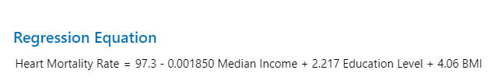
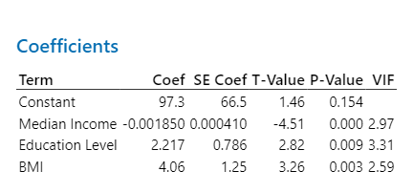
Here we see the relationship our independent predictors have on heart mortality rates. Firstly, we have our constant or intercept. In this case it doesn’t really have much meaning since none of our predictors will ever in any real situation be at zero, but this constant would indicate what our expected heart disease mortality rate would be if all our predictors were zero. (Southekal, 2024) Secondly, we see the coefficient values and their relationship to the dependent variables. For example, for every 1 dollar increase in median income we can see a negative 0.001850 units (mortality rates) percentage points. Also, education level could be read as for every 1 percent increase in education level we can see the expect heart disease mortality rate increase by 2.217 percentage points or units. Lastly, BMI can be expressed as 1 unit increase in BMI we see a corresponding increase in heart mortality rate by 4.06 percentage points.
P-Values, Model Summary and Relationship to Hypothesis for Heart Morality Rates in 2022
All p-values contain a significance of 0.01
The p-values are as follows: median income scored significantly at 0.000 which indicates that there is a strong statistically significant relationship between median income and heart disease morality rates for 2022 for the selected states. With this significance we can say there is also strong evidence to support the conclusion that higher median incomes could be associated with lower heart disease mortality rates for 2022. Secondly, we can see that education levels scored 0.009. This suggests that there is strong statistical evidence from our dataset to conclude that as education levels increase, we are also seeing an increase in higher heart disease mortality rates. This is a counterintuitive finding but might be explained by other factors. For instance, higher education individuals could disproportionally work in office settings leading to sedentary lifestyles etc. However, additionally analyses may need to be done to help understand why this is the case. Lastly, we can see that BMI scored a p-value of 0.003 this indicates that higher BMI are significant to higher heart disease mortality rates.
Model Summary
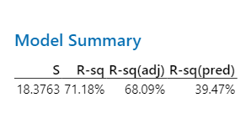
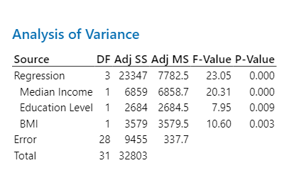
In this output table we can see that the standard deviation is 18.3763 which we want to see a smaller deviation to express better fit to our data. With our dependent variable values at upwards to 150 percent and higher by death rate we can see this deviation isn’t so extreme. (Statistics Canada, 2021) Secondly, we have an R squared value listed at 71.18 percent which tells us that our model can explain 71.18 of the variability in heart disease mortality rates. This indicates a relatively good fit for the model. Secondly, we see that R square adjusted drops our values to 68.09 percent. Even with taking into consideration the number of predictors this is a good fit to explain our dependent variables variability. However, it should be noted that with a predicted R squared of 39.47 our model might not simplify well with new datasets or could indicate overfit. Also, the model could become tailored to the sample data (Minitab, 2024)

Preliminary results for Diabetes Mortality Rates.
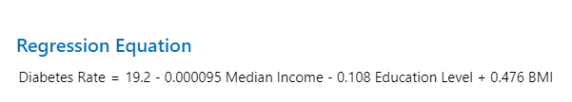
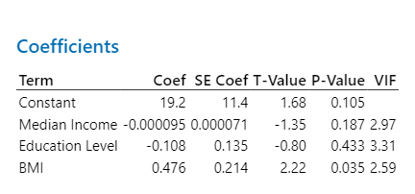
For the sake of brevity and being as we laid the groundwork in the previous section on the specificity of initial results, we will explain the output in a more succinct form and how it relates to our hypothesis an if any counterintuitive or inconsistent elements that may exist.
Primarily, we see a starting point of 19.2 with all predictors at zero. In addition, we see several significant findings. The relationship indicated by median incomes states that one dollar increase in median income is associated with a decrease in 0.000095 percentage points or units. With a p-value of 0.187 we can see that median income does not have a statistically significant relationship to diabetes rates based upon our sample for 2022. Next, we have a coefficient of -0.108 as it relates to diabetes rates. With the p-value of 0.433 we can see that this too was found to be insignificant as it relates to diabetes rates for 2022. However, we did see that BMI is significantly related to diabetes rates with an indicated p-value of 0.035 and a coefficient of 0.476 increase of diabetes rates to one unit change in BMI unit change. This isn’t very surprising as temporal trends in community records which include hospital and ambulatory data illustrates that increase in BMI are significant with increases in diabetes cases. (Leibson et al., 2001)
Model Summary
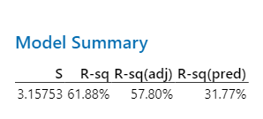
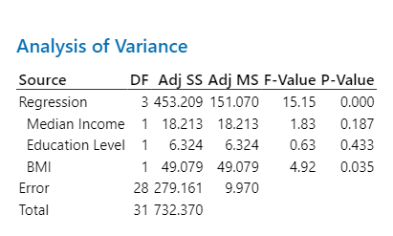
Under this analysis, we can see that our standard deviations given our dataset values are good. Diabetes rates can have ranges up to the 40 in terms of percentage rates which correlates nicely with our smaller deviation. Next, we can see that 61.88 percent of the variability in our dependent variable can be explained using our predictors which is a relatively good fit. Secondly, our adjusted value too indicates good explanatory power and fit. As stated with our heart disease analysis we can see that with a 31.77 percentage for R square predicted, our model might not be able to predict and handle new datasets or that our model is overfitting our data. (Frost, 2017) Lastly, with F-Value of 15.15 and p-value of 0.000 we can see that the fit for our model is highly significant as overserved and stated previously from the p-value data on each predictor. Finally, though it is not inconsistent, it seems mildly counter intuitive that we should see median income play a more substantial role in diabetes mortality rates being a health condition as heart disease. But other factors may be at play that need investigated.
OLS Violations and Other Statistical Tests
Diabetes

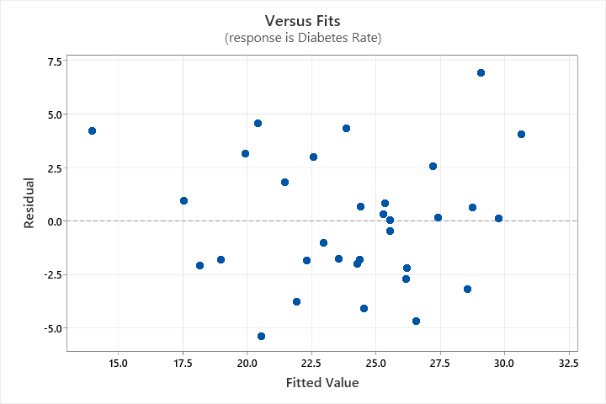
Heart Disease

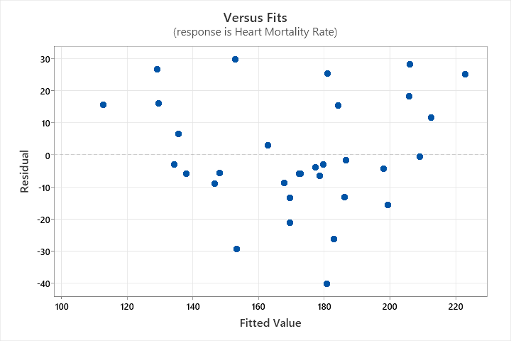
Residuals vs Fitted Plots
From the given results above, we can see that the scattering of residuals for heart disease mortality rates appears to have some clustering at the 140 to 180 marks. This slight clustering could indicate mild forms of heteroscedasticity, and we may need to perform Breusch-Pagan or White Test to then address if this is the case. However, with our diabetes data, there doesn’t appear to be any funneling and the residual plots appear to be more evenly spread out.
Outliers and Cooks Distance Heart Disease Mortality Rates
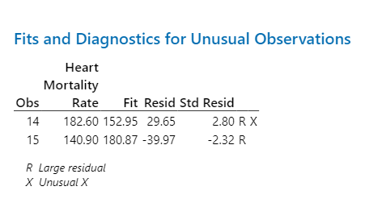
0.02501 0.05834 0.00008 0.00124 0.00337 0.00048 0.09461 0.00584 0.00011 0.00135 0.03608 0.00579 0.00646 0.00178 0.09996 0.08382 0.00059 0.01588 0.19207 0.03967 0.00603 0.00167 0.05479 0.00451 0.00116 0.10794 2.67380 3.90921 0.01565 0.19012 0.05171 0.01667 0.05315 0.11970 0.02321 0.00736 0.00298 0.00094 0.01333 0.00016 0.01279 0.00068 0.00102 0.00710 0.00130 0.00002 0.00007 0.01400 0.01709 0.00088 0.24019 0.49791 0.01487 0.00350 0.00000 0.02226 0.01059 0.08076 0.09560 0.10824 0.00944 0.00917 0.00288 0.00073
When looking at the outlier information for heart disease mortality we can see that there appears to be several outliers that could be affecting our model and outcome. For instance, the standardized residual values of 2.80 for observation 14 suggests that this is a significant outlier in terms of size and has an unusual predictor value. Additionally, we can also see from observation 15 that it exceeds our standardized values as well. Additionally, we can also see that this value corresponds with a highly significant cook value of 2.67380 which means that this is also playing a significant effect on our results and regression. However, for our 14 observations, the corresponding cook value 0.0156474 appears to be slightly mild in its influence. However, more notable cook distances of 3.90921 will need to be assessed as well.
Outliers and Cooks Distance Diabetes Mortality Rates.
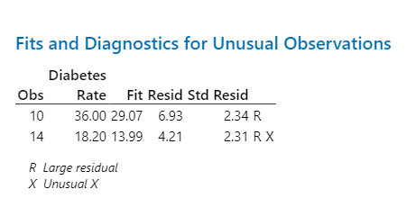
0.02501 0.05834
0.00008 0.00124
0.00337 0.00048
0.09461 0.00584
0.00011 0.00135
0.03608 0.00579
0.00646 0.00178
0.09996 0.08382
0.00059 0.01588
0.19207 0.03967
0.00603 0.00167
0.05479 0.00451
0.00116 0.10794
2.67380 3.90921
0.01565 0.19012
0.05171 0.01667
0.05315 0.11970
0.02321 0.00736
0.00298 0.00094
0.01333 0.00016
0.01279 0.00068
0.00102 0.00710
0.00130 0.00002
0.00007 0.01400
0.01709 0.00088
0.24019 0.49791
0.01487 0.00350
0.00000 0.02226
0.01059 0.08076
0.09560 0.10824
0.00944 0.00917
0.00288 0.00073
From the data listed above we can see there appears to be two significant values that have large residuals as well as unusually large values which could be affecting our analysis for diabetes. In addition, the corresponding cook distance for observation 14 is 2.67380 which illustrates that there appears to be a significant influential point and may be heavily impacting our models’ coefficients and predictors. Furthermore, the observation value 10 only has a cook distance of 0.192071 and appears to be below the significant threshold.
Effect on Results
With the effects of influential points determined by our cook’s distance of greater than one, we can see that these large distances can crease a biased effect on our coefficients. Thusly, incorrectly effecting our interpretation of results. Additionally, these points can increase our standard errors leading to an increase in our confidence intervals thus masking predictor significance. Secondly with the data points from heart disease mortality rates clustering, we can see that this heteroskedasticity could influence our conclusions and make Type 1 or Type 2 errors more prevalent. (Prep , 2022) Finally, the outliers determined can distort our predictions and coefficients. Moreover, they can also affect our R squared values or goodness of fit for our model. (Bock, 2017)
Next Steps
With these values determined, we will need to employ several tests and techniques to address these various violations. Firstly, with the significant cook’s value points and outliers we will need to either transform or remove these influential points to therefore get more robustness out of our model. (Johnson et al., 2023) For possible heteroscedasticity we could transform (Log) the response variable to help eliminate potential problems and stabilize variances. Finaly, it should be noted that these are only a select few of the violations, as we proceed to our secondary results, we will address other OLS violations if they occur and how to address these issues as well as discuss more results from our testing.
Secondary Results
Some secondary results were covered in the previous section as well as the anticipation of some OLS violations. In this section I will talk about more secondary results found as well as add some additional tests to look for issues with the data and outcomes.
Diabetes Rates Regression
Heart Disease Rates Regression
Fundamentally, when analyzing multiple regression models, we need to see if multicollinearity is present in variables. In Minitab, this is expressed as VIF or Variance Inflation Factors. In this case all our values are 1 and 5. While this does indicate moderate range, it is not really a cause for concern and is generally excepted. (The Investopedia Team , 2024) Anything above a 5 could be problematic in our model’s execution and interpretation. (The Investopedia Team, 2024) If multicollinearity were to exist, we would see issues with instability of coefficients as well as problems with p values etc. and reduced predictive power. When analyzing our heart disease VIF’s we can see that none prose a significant problem for our model.
Diabetes Rates Regression
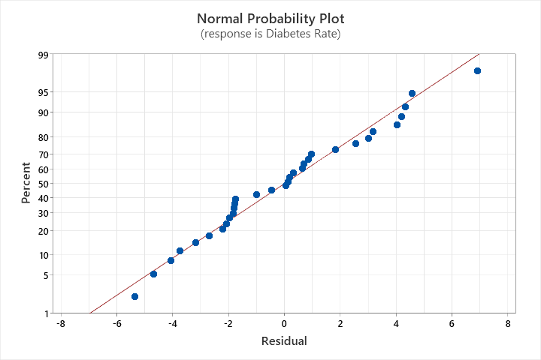
Heart Disease Rates Regression

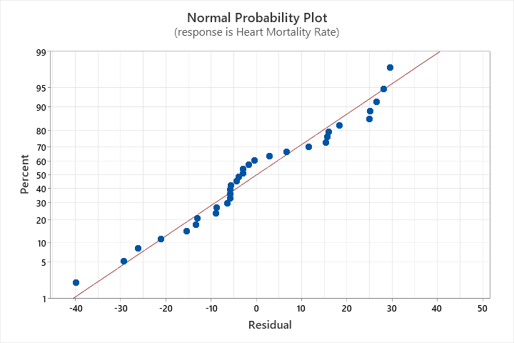
Here we have plotted a Q-Q plot to help us understand if our residuals form a normal distribution to help us ensure that our model parameters as well as our p values are valid. For Diabetes Mortality Rates we can see that they follow relatively close to our 45-degree line indicating a good normal distribution. There does appear to be some slight S movements in the residual values, this could be indicative of mild skewness but only slightly. This could pose a problem and indicate a slightly less variance than expected. (Skymark, 2024) There is some slight tailing with both indicating larger variances and outliers at these specific points. This was determined by our outlier analysis previously and is being shown here graphically in relation to other data points. Additionally, we see this a bit more abrupt in our Heart Disease Mortality output with the S movements looking more aggressive. However, even with this slight movement, it doesn’t appear to be too drastic and as stated previously there are things we can implement to fix this even further for normal distribution effects.
Additional Tests for more Secondary Results
Diabetes Mortality Regression

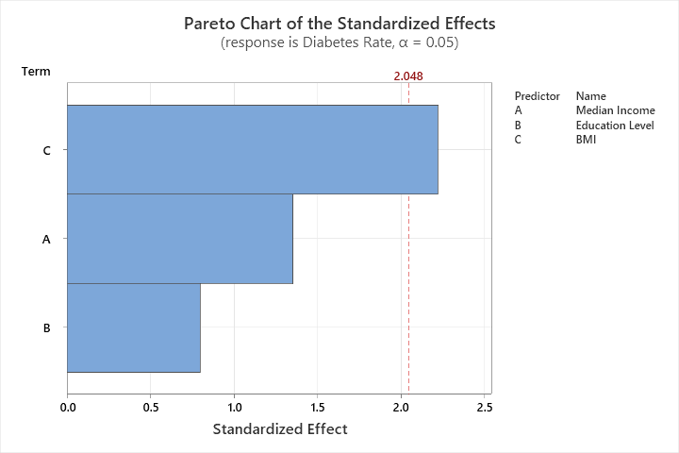
Here we have listed more results for robustness as well as autocorrelation effects. A Durbin-Watson value of 1.93864 indicates that no significant autocorrelation is occurring for data points and variables. (Kenton , 2019) Secondly, we have a Pareto chart which can help us break down our analysis even more to see if statistical significance for our response variable exists. This also can lead us in directions for further study and investigation. Here we see that BMI has crossed our significance line, so its effect size has shown to be substantial. Here if we were inclined can help us determine why this is the case.
Heart Disease Mortality Rates

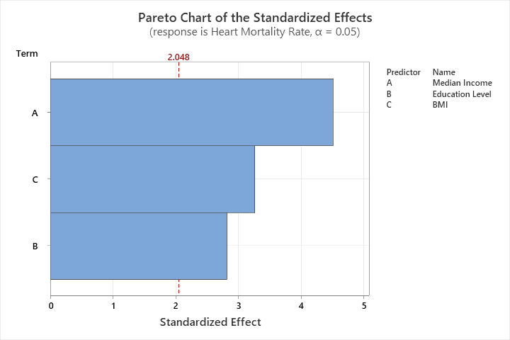
Here we see a slightly higher Durbin- Watson statistic but good in terms of autocorrelation and is generally not a problem. We can see that the model is capturing our relationship satisfactorily which helps our robustness. If there were autocorrelation issues, we could see in heteroskedasticity as well as in bad model predictions and estimates. (Glen , 2021) Also, we see that there is significance effects on all of our variables to Heart Disease Mortality. This can give us a good starting point in determining why these relationships are existing and provide more significant analyses to pinpoint these effects. These results show that there is relatively an absence of serious issues with residuals etc. as was also previously stated from our previous tests on these subjects.

Corrections and Effects
With minor heteroskedastic behaviors in both our heart and diabetes analysis, I will remove all significant cook values and outliers to illustrate any effects this might have on our data. Though not discussed previously, only one leverage value appeared significant for one observation (District of Columbia) with a noted value of 0.666838. I will also remove this to see what significance it might play in our corrected analysis. Lastly, all leverage and cook values removed will need to have a significance of close to 1. This rule will also be applied to squared values. With these eliminated the following output is as follows.
Heart Mortality Rate (Adjusted)
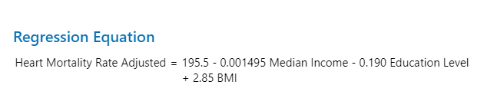
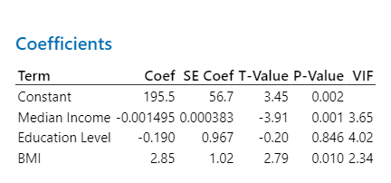
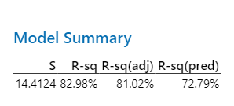
With the outliers removed and subsequently the rows that contained them in our analysis we can see the following values. For instance, it seems that the relationships of both Median Income and Education Levels retained their respective signs but with a reduction in their overall coefficients. This indicates that the relationships are not as profound in their proportions as in the non-adjusted model. Both models showed that BMI is associated with higher heart disease mortality rates but not as profound as the previous model indicated. Comparing our R Squared values we can see that this new model is much better in its prediction with 82.98 percent. In addition, the standard errors in the new model also look much more precise with a reduction from 18.3763 to 14.4124. Interestingly, with the old and new models we had seen statistically significant p-values with both Median Income and BMI. However, with the exclusions of our outliers etc. we can see that now Education Levels are no longer statistically significant. This greatly effects our conclusions as now education appears insignificant so the relationship may have been influenced by the outlier data from our observations. This may need to be further investigated to understand why this happened and the magnitude of what might be causing it. Additionally, the newer models appear to better capture the complexities of our variables better than our older models. This is exceptionally true of Heart Disease Mortalities both in predicting and generalizing new data and in overall fitness with included predictors and explanation of variance. (Minitab Blog Editor, 2013) Overall, the magnitude of the relationships seems to be more pronounced than our previous conclusions but still significant outside the change in significance with education levels. VIF levels appear to be relatively good sitting between 2 and 4 in magnitude which is moderate but not problematic for analysis as previously discussed.
Diabetes (Adjusted)
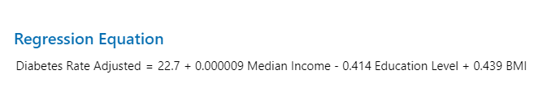
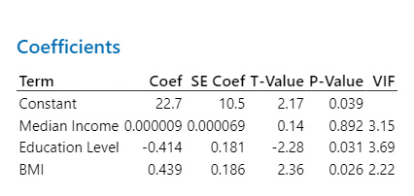
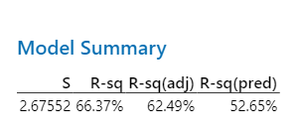
One thing of significance is the fact that Median Income has changed from a negative effect (-0.000095) to a slight positive effect (0.000009). This small shift, due to its insignificance as a predictor may not indicate anything of substantial value in our analysis. Education became more negative in this newer model perhaps indicating a stronger relationship. Lastly, BMI remained stable 0.476 to 0.439 but still a positive influence. Median Income remained insignificant in both the newer and older models not effecting our previous conclusions. Interestingly, Education Levels moved from insignificant to significant suggesting that further study needs to be done as to why this has occurred. Also, this effects our overall conclusions previously mentioned in that something within the data omitted is causing significant changes in our results. Even with the newer model, BMI still showed significant. The newer model showed a better R Squared compared to older model. Also, the R Adjusted increased indicating a better ability in the newer model to explain variation when accounting from predictors. Also, predictive R Squared values show better performance from new data. (Minitab Blog Editor, 2013) Lastly, multicollinearity showed slight increases in Education Levels but not too significant. Also, Median Income jumped significantly to 3.15 with a reduction to 2.22 for BMI indicated all contained relatively low multicollinearity in both models. This shows that the predictive relationships of both model’s predictors are not correlated highly with one another thus their coefficient are not significantly impacted. (Lean Sigma Corporation, 2016)
Statistical Significance for Heart Disease Mortalities
We found that in the newer adjusted model, the constant became statistically significant indicating that the newer model’s baseline is confident form zero providing all other variables are zero (which is impossible). Therefore, this metric really isn’t of high value but is useful for looking at the trends of heart disease mortalities overall. A very important metric that was found statistically significant was Median Income to Heart Disease Mortality which were found to be significant in both new and adjusted models. However, the adjusted model does show that the significance has decreased slightly most likely due to the removal of outlier and large residual observations. Tying back into the hypothesis and research question we can see that the null hypothesis is false and that there does exist a significance of Median Income to Heart Disease Mortalities in 2022 for the selected states. The economic significance of this is profound. Given that the reduction of the old model to new model was slight (-0.001850 down to -0.001495) we can see that even 1000 increase in income could reduce heart disease mortalities by 1.45-1.85 percentage points. This could prove immense in overall population numbers. Economically, it should be worth looking into to see how governments can extend opportunities to individuals to capitalize on income increases though subtractive or direct measures within their communities. Additionally, as we will analyze, these p values for Median Income are even more significant than our BMI and Education Levels values for this model. Additionally, we see that BMI remained significant with both models. To tie this into our hypothesis, we can say that we reject the null hypothesis and that though the new model as reduced the relationships effects, 8.55 to 12.18 Heart Disease Mortality death per 100,000 proves a very substantial number when multiplied to the total population of the United States. Lastly, due to the nature of significance with Education Levels, we can see that the old model showed promise while the new model showed no significance. This means that the null hypothesis was rejected in the old model and then accepted in the new one. Illustratively, we could see that if specific sections of the United States could have increases in education attainment at the bachelor’s levels, shockingly an increase in mortality rates via heart disease could follow. However, due to the changes in significance, other factors like BMI and income should be prioritized over education. Regarding BMI, these additional economic costs due to the significant magnitude of coefficients and their applicable predictions to populations, could prove a substantial healthcare cost to individuals and families. Helping to control BMI and reducing its impact could save a significant amount in healthcare costs etc.
Diabetes Statistical Significance
Under our diabetes analysis, we can see that there appears to be no significant relationship between Median Income and Diabetes Morality Rates. Therefore, we accept the null hypothesis and as an illustrative and economic example, policy prescriptions should not need to focus on discrepancies in income as it relates to diabetes mortalities. Even if discretions exist by state or region for 2022, no significance was found to effect mortality rates. With BMI we can see that with both new and old model there appears to be good significance. Therefore, the null hypothesis is rejected, and a significance difference is accepted therefore by regions and states we can see that if comparing BMI’s, we might see significance between these regions due to the regression relationships. Education Levels, due to the becoming insignificant in older models and significant in our newer models, will need to be further investigated within the outlier information omitted to provide more testing to see if Education does in fact warrant a significant relationship to Diabetes Mortality Rates and why this is occurring in the datasets.
Conclusion Actionable Insights or Recommendations
I will lay out my recommendations and in doing show illustrate points of convergence and divergence with my literature review studies. From my analysis above, we can see that Median Income illustrated a significantly negative (-0.001495) relationship with Heart Disease Mortality. For a relatable insight, this means that if the population could effectively increase their income by merely 10,000 dollars per person, we could see a reduction of mortality rates by approximately 1.49 percentage points! This is just an aggregate effect but one that could create a protective effect against heart disease mortalities. With multiplicative effects from income (Ganti , 2024) we could have seen an increased reduction of heart disease mortality for 2022. A simple recommendation for this is to see how these income inequalities could be remedied or at least mitigated for the purpose of providing a significant reduction of these relationships. Interestingly, this was also the conclusions drawn from Andrew Bourne et al. and their analyses. What was concluded was those economic factors such as poverty, unemployment, exchange rates have been shown to significantly affect health outcomes. (Andrew Bourne et al., 2014) Several ways could be recommended to help increase potential incomes with a focus in poverty-stricken areas. Primarily, other recommendations that could be provided would include strengthening economic programs by way of encouraging companies to promote job training, skill attainment as well as providing more access to health care and expansions in effected areas. This has been affected in a study illustrating skill acquisition (entrepreneurial) and unemployment. (Ezeanokwasa & Nwachukwu, 2014) Additionally, governments could use this research as an actionable guide in decision making processes to provide quantitative easing as well as wage growth initiatives though unionization, job creation by sectors and promotion of free trade agreements. (The Investopedia Team , 2024a) (Hur & Park, 2012) (MK & Vethirajan, 2021) However this could result in mixed results of other counties involved. This was also seen from previous studies. Primarily, analyzing time data through Fourier analysis, Brenner concluded that economic downturns specifically in NY state contributed to long term effects in heart disease mortalities and complications. He also recommended that times of economic stability and controlling for these instabilities might help reduce some of these effects. (Brenner, 1971)
Though this has been discussed at some length, it was also shown from our analysis that BMI had a very high significance with Heart Disease and Diabetes Morality Rates. For some insight, our adjusted results showed that one point increase in BMI increased heart disease rates by 2.85 percentage points and diabetes rates 0.439 respectively. If an individual were to move just 5 points in their BMI, this would result in 14.25 percent increase in heart disease mortality. Additionally, this could also result in a 2.2 percent increase in diabetes mortality. Perhaps furthering help with education on dieting behaviors as well as access to and promotion of physical activity and healthcare measures could help prevent some effects of obesity (Lang & Froelicher, 2006) on heart disease and diabetes risks. Lastly, there appeared to not be a significant economic or confounding factor (besides BMI) that had a significant relationship to diabetes mortality rates. My future recommendation would be to look at other compounding effects to see if other factors such as access to health care or economic factors (inflation) could be contributing to these effects. More could be discussed about this, but the primary take away would be to recommend balancing health and economic integration when it comes to policy implementation, prescription or advocation. Finally, due to the changing significance in Education Levels from adjusted to non-adjusted model changes, I recommend further analysis into why these switching effects are occurring. It could also be due to the large residual and outlier effects from the data gathered.
Conclusion Results
Overall Results
With non adjusted models, we had seen a relatively high significance of Heart Disease Mortality Rates with Median Income, BMI and Education Levels for 2022. For our adjusted models, we seen that Median Income reduced in its significance and Education Levels became not significant to Heart Disease Mortality rates for 2022. Additionally, non-adjusted models indicated that Diabetes Mortality Rates were not significant with Median Income or Education Levels in 2022. However, we did find it to be significant with BMI. With adjusted models, we seen that diabetes mortality rates became significant with BMI when previously it was not. Also, most of our models illustrated better predictive effects and overall R-Square values indicating higher explanation of variables. VIF numbers (indicating if a change in BMI, Education and Median Income show changes within each other) for both diabetes and heart disease remained relatively good at around 2-3 with education levels under the adjusted Heart Mortality Rate model at 4. Heteroskedasticity (the even spread of our data points or residuals) and normality plotting appears relatively normal for non-adjusted models, however heteroskedasticity appeared to cluster in Heart Disease Mortality adjusted models.
While conducting these studies some limitations have been noticed. Primarily, I’ve recognized that increasing the number of states in my study for 2022 could be an effective treatment as smaller sample sizes (states) could be more prone to outliers and data concerns. This means any state or metric that was profoundly further way from other states analyzed. Also seeing large differences by looking at data points of what we expected to happen vs what was occurring. However, due to the number of variables and some research conducted, I think this sample size could still be effective in providing significant results and analysis. (Complete Dissertation, 2024) Another big concern, as was applied from my literature review of Dr Brenner’s work on economic changes and heart disease mortality. Primarily, within these studies was the use of Fourier analysis (taking large data patterns and breaking them into smaller, simpler patterns to analyze) in uncovering potential trends in these variables as well as other cyclical factors like seasons for separating long term and short-term trends in our data. (Brenner, 1971) Being as our study uses only linear regression models and contains data only from 2022, equal changes in our variables might not be causing equal results and utilizing underlying cyclical patterns and trends in variables are limited because we are only looking at one year of data.
Additionally, it should be noted that my confounding variable (these are variables I used like BMI and Education Levels) could pose some significant caveats. Education defined could be too broad in its applications and could be capturing some redundancy to other variables thus effecting mortality. (Rangan Jayakumar, 2024) Additionally it could also be affecting the outcomes of health and income. (Frost, J. (2017, October 31). It should be noted that I did see a significant relationship (positive) of BMI and educational levels which needs be explored more or if broken down more effectively could show us better relationships.

References
Andrew Bourne, P., Mills , M., Campbell-Smith, J., Sharpe-Pryce, C., Francis, C., Solan, I., & Davis , A. H. (2014). The Influence of Macroeconomic Variables on Health Indices, Murder and Mortality: A Case of Jamaica. Journal of General Practice, 02(02). https://doi.org/10.4172/2329-9126.1000145
Brenner, M. H. (1971). Economic changes and heart disease mortality. American Journal of Public Health, 61(3), 606–611. https://doi.org/10.2105/ajph.61.3.606
Benoit, K. (2011). Linear Regression Models with Logarithmic Transformations. https://links.sharezomics.com/assets/uploads/files/1600247928973-from_slack_logmodels2.pdf
Beran, T. N., & Violato, C. (2010). Structural equation modeling in medical research: a primer. BMC Research Notes, 3(1). https://doi.org/10.1186/1756-0500-3-267
Bock, T. (2017, July 30). 8 Tips for Interpreting R-Squared. Displayr. https://www.displayr.com/8-tips-for-interpreting-r-squared/#:~:text=Similarly%2C%20outliers%20can%20make%20the
Burnham, K. P., Anderson, D. R., & Springerlink (Online Service. (2002). Model Selection and Multimodel Inference : A Practical Information-Theoretic Approach. Springer New York.
CDC. (2022). BRFSS Prevalence & Trends Data: Explore by Topic | DPH | CDC. Nccd.cdc.gov. https://nccd.cdc.gov/BRFSSPrevalence/rdPage.aspx?rdReport=DPH_BRFSS.ExploreByTopic&irbLocationType=StatesAndMMSA&islClass=CLASS14&islTopic=TOPIC09&islYear=2022&islLocation
Centers for Disease Control and Prevention. (2022, February 25). Stats of the States - Heart Disease Mortality. Centers for Disease Control and Prevention. https://www.cdc.gov/nchs/pressroom/sosmap/heart_disease_mortality/heart_disease.htm
CenterStat. (2019, January 23). Can I estimate an SEM if the sample data are not normally distributed? CenterStat. https://centerstat.org/can-i-estimate-an-sem-if-the-sample-data-are-not-normally-distributed/
Complete Dissertation . (2024, April 17). Sample Size Formula. Statistics Solutions. https://www.statisticssolutions.com/dissertation-resources/sample-size-calculation-and-sample-size-justification/sample-size-formula/#:~:text=A%20sample%20size%20that%20is
Ezeanokwasa, F., & Nwachukwu, O. (2014). Effective Entrepreneurship Skills in Reducing Unemployment through Small Business Innovation in Nigeria. https://core.ac.uk/download/pdf/234671855.pdf
FRED. (2022a). 2020, Release Tables: Real Median Household Income by State, Annual | FRED | St. Louis Fed. Fred.stlouisfed.org. https://fred.stlouisfed.org/release/tables?eid=259515&rid=249
FRED. (2022b). 2021, Educational Attainment, Annual: Bachelor’s Degree or Higher by State | FRED | St. Louis Fed. Fred.stlouisfed.org. https://fred.stlouisfed.org/release/tables?eid=391444&rid=330
Frost, J. (2017). How to Interpret Adjusted R-Squared and Predicted R-Squared in Regression Analysis - Statistics By Jim. Statistics by Jim. https://statisticsbyjim.com/regression/interpret-adjusted-r-squared-predicted-r-squared-regression/
Frost, J.(2017, October 31). Understanding Interaction Effects in Statistics - Statistics By Jim. Statistics by Jim. https://statisticsbyjim.com/regression/interaction-effects/
Ganti , A. (2024, July 9). What Is the Multiplier Effect? Investopedia. https://www.investopedia.com/terms/m/multipliereffect.asp#:~:text=The%20multiplier%20effect%20refers%20to
Gao, S., L. Mokhtarian, P., & A. Johnston , R. 2002. (2008). Non-normality of Data in Structural Equation Models . https://escholarship.org/content/qt11q0s48s/qt11q0s48s.pdf?t=lnrp0r#:~:text=In%20SEM%2C%20one%20of%20the,a%20multivariate%20non%2Dnormal%20distribution.
Glen , S. (2021, August 16). Finding and Fixing Autocorrelation - DataScienceCentral.com. Data Science Central. https://www.datasciencecentral.com/finding-and-fixing-autocorrelation/
Greene, W. H. (2017). Econometric analysis. Pearson.
Heckman, J. J. (1979). Sample Selection Bias as a Specification Error. Econometrica, 47(1), 153–161.
Household Income in States and Metropolitan Areas: 2022. (2023). KEY DEFINITIONS. https://www.census.gov/content/dam/Census/library/publications/2023/acs/acsbr-017.pdf
Hur, J., & Park, C. (2012). Do Free Trade Agreements Increase Economic Growth of the Member Countries? World Development, 40(7), 1283–1294. https://doi.org/10.1016/j.worlddev.2011.12.006
Johnson, G. H., Omidi, H., & Rezoanul Hoque, M. (2023). What are the most effective techniques for dealing with regression outliers? Linkedin.com. https://www.linkedin.com/advice/1/what-most-effective-techniques-dealing-regression-ogvrc#:~:text=One%20approach%20is%20to%20use
Kenton , W. (2019). Understanding the Durbin Watson Statistic. Investopedia. https://www.investopedia.com/terms/d/durbin-watson-statistic.asp
KFF. (2024, May 24). Total Diabetes Deaths | KFF. KFF. https://www.kff.org/other/state-indicator/diabetes-death-rate-per-100000/?activeTab=map¤tTimeframe=0&selectedDistributions=diabetes-death-rate-per-100000&sortModel=%7B%22colId%22:%22Location%22
Kline, R. B. (2015). Principles and practice of structural equation modeling (pp. 79–105, 239–275.). New York Guilford.
Kutner, M. H., & Neter, J. (2004). Applied Linear Regression Models. Irwin/McGraw-Hill.
Lang, A., & Froelicher, E. S. (2006). Management of Overweight and Obesity in Adults: Behavioral Intervention for Long-Term Weight Loss and Maintenance. European Journal of Cardiovascular Nursing, 5(2), 102–114. https://doi.org/10.1016/j.ejcnurse.2005.11.002
Lean Sigma Corporation. (2016, January 14). Multiple Linear Regression with Minitab - Lean Sigma Corporation. Lean Sigma Corporation . https://leansigmacorporation.com/multiple-linear-regression-with-minitab/
Leibson, C. L., Williamson, D. F., Melton, L. J., Palumbo, P. J., Smith, S. A., Ransom, J. E., Schilling, P. L., & Narayan, K. M. V. (2001). Temporal Trends in BMI Among Adults With Diabetes. Diabetes Care, 24(9), 1584–1589. https://doi.org/10.2337/diacare.24.9.1584
Minitab. (2024). Model summary table for Fit Regression Model. Minitab.com. https://support.minitab.com/en-us/minitab/help-and-how-to/statistical-modeling/regression/how-to/fit-regression-model/interpret-the-results/all-statistics-and-graphs/model-summary-table/#:~:text=about%20the%20population.-
Minitab Blog Editor. (2013). Multiple Regression Analysis: Use Adjusted R-Squared and Predicted R-Squared to Include the Correct Number of Variables. Minitab.com. https://blog.minitab.com/en/adventures-in-statistics-2/multiple-regession-analysis-use-adjusted-r-squared-and-predicted-r-squared-to-include-the-correct-number-of-variables
MK, G., & Vethirajan, Dr. C. (2021). Skill Development Initiatives and Employment Opportunity in India. SSRN Electronic Journal. https://doi.org/10.2139/ssrn.3827893
Mohr, D. L., Wilson, W. J., & Freund, R. J. (2021). Statistical Methods. Academic Press.
Montgomery, D. C., Peck, E. A., & G Geoffrey Vining. (2012). Introduction to linear regression analysis. Wiley.
Prep , A. (2022, December 20). Explain the Types of Heteroskedasticity and How It Affects Statistical Inference. CFA, FRM, and Actuarial Exams Study Notes. https://analystprep.com/study-notes/cfa-level-2/quantitative-method/explain-the-types-of-heteroskedasticity-and-how-it-affects-statistical-inference/
Rangan Jayakumar, T. (2024). Understanding Multicollinearity in Regression | Built In. Built In. https://builtin.com/articles/multicollinearity#:~:text=Inclusion%20of%20Irrelevant%20Variables
Raudenbush, S. W., & Bryk, A. S. (2002). Hierarchical linear models : applications and data analysis methods. Sage Publications.
Skymark . (2024). Normal probability plot: Does your data follow the standard bell curve? Skymark.com. https://www.skymark.com/resources/tools/normal_test_plot.asp#:~:text=Short%20Tails%20%2D%20An%20S%20shaped
Southekal, P. (2024, April 26). Understanding Linear Regression Intercepts in Plain Language. DATAVERSITY. https://www.dataversity.net/understanding-linear-regression-intercepts-in-plain-language/#:~:text=The%20intercept%20or%20constant%20in
Statistics Canada. (2021, September 2). Statistics: Power from Data! Variance and standard deviation. Statcan.gc.ca. https://www150.statcan.gc.ca/n1/edu/power-pouvoir/ch12/5214891-eng.htm
The Investopedia Team . (2024a, April 28). What Is Quantitative Easing (QE), and How Does It Work? (E. Rasure & D. Rubin , Eds.). Investopedia. https://www.investopedia.com/terms/q/quantitative-easing.asp#:~:text=Quantitative%20easing%20is%20a%20type
The Investopedia Team . (2024). Variance Inflation Factor (VIF) (R. C. Kelly & T. Li, Eds.). Investopedia. https://www.investopedia.com/terms/v/variance-inflation-factor.asp#:~:text=The%20higher%20the%20VIF%2C%20the
Tourangeau, R., & Yan, T. (2007). APA PsycNet. Psycnet.apa.org. https://psycnet.apa.org/record/2007-12463-007
Vaughn, L. M., Jacquez, F., & Bakar, R. C. (2009). Cultural Health Attributions, Beliefs, and Practices: Effects on Healthcare and Medical Education. The Open Medical Education Journal, 2(1). https://benthamopen.com/ABSTRACT/TOMEDEDUJ-2-64

